

FAIRMONT AMBASSADOR SEOUL ROOM RESERVATION FORM
[ICOMES 2026]
In order to secure a room at Fairmont Ambassador Seoul, please fill up this page and e-mail to
us with the appropriate information.

E-MAIL: nina.park@fairmont.com

** Stay Period : 01 September (Mon) – 08 September (Tue)
** Except on 05 September (Sat)

ROOM TYPE | DAILY RATE (VAT Inc)  ** ROOM ONLY ** | INCLUSION
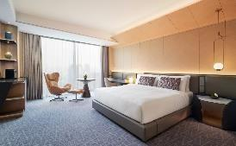  Fairmont Room (42 sqm) | KRW 418,000 Inc | Complimentary Access to Fitness Center &  Indoor Swimming pool  Complimentary WIFI
Check in 15:00 / Check out 11:00

GUEST INFORMATION
First Name |  | Last Name
Telephone | + | E-mail

ROOM
Check-in Date |  | Check-out Date
Room Type | KING ☐ | Number of guests | 1 ☐ 2☐
Special
Requirements

CREDIT CARD DETAILS
Type | American Express ☐ VISA ☐ MASTER ☐ BC ☐
Number |  | Valid  Date | MM/YY

CANCELLATION POLICY
7 Days prior to arrival to avoid one night cancellation penalty.

SIGNATURE: DATE:

